9.利用Matlab GUIDE设计一个简单信号分析仪的程序，要求根据输入的两个频率和时间间隔，计算函数 x=sin(2πf1t)+sin(2πf2t) 的值，并对函数进行快速傅立叶变换，最后分别绘制时域和频域的曲线。该实验将验收。

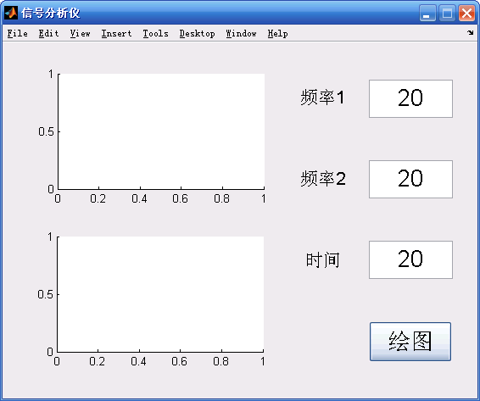

function varargout = untitled(varargin)

gui_Singleton = 1;

gui_State = struct('gui_Name', mfilename, ...

'gui_Singleton', gui_Singleton, ...

'gui_OpeningFcn', @untitled_OpeningFcn, ...

'gui_OutputFcn', @untitled_OutputFcn, ...

'gui_LayoutFcn', [] , ...

'gui_Callback', []);

if nargin && ischar(varargin{1})

gui_State.gui_Callback = str2func(varargin{1});

end

if nargout

[varargout{1:nargout}] = gui_mainfcn(gui_State, varargin{:});

else

gui_mainfcn(gui_State, varargin{:});

end

function untitled_OpeningFcn(hObject, ~, handles, varargin)

handles.output = hObject;

guidata(hObject, handles);

function varargout = untitled_OutputFcn(~, ~, handles)

varargout{1} = handles.output;

function f1_input_CreateFcn(hObject, ~, ~)

if ispc

set(hObject,'BackgroundColor','white');

else

set(hObject,'BackgroundColor',get(0,'defaultUicontrolBackgroundColor'));

end

function f2_input_CreateFcn(hObject, ~, ~)

if ispc

set(hObject,'BackgroundColor','white');

else

set(hObject,'BackgroundColor',get(0,'defaultUicontrolBackgroundColor'));

end

function t_input_CreateFcn(hObject, ~, ~)

if ispc

set(hObject,'BackgroundColor','white');

else

set(hObject,'BackgroundColor',get(0,'defaultUicontrolBackgroundColor'));

end

function pushbutton1_Callback(~, ~, handles)

f1=str2double(get(handles.f1_input,'String'));

f2=str2double(get(handles.f2_input,'String'));

t=eval(get(handles.t_input,'String'));

x=sin(4*pi*f1*t)+sin(4*pi*f2*t);

y=fft(x,520);

m=y.*conj(y)/520;

f=1000*(0:256)/520;

axes(handles.frequency_axes)

plot(f,m(1:257))

set(handles.frequency_axes,'XminorTick','on')

grid on

axes(handles.time_axes)

plot(t,x)

set(handles.time_axes,'XminorTick','on')

grid on

